# [C:\Users\jwoo5\AppData\Local\Temp\templateTermTutorial.html](http://www.calstatela.edu/centers/hipic) BUS 5100 Term Project Tutorial https://avatars2.githubusercontent.com/u/4156894?v=3&s=100

Group 1California State University, Los Angeles

#### Authors: Loc Bryan Truong  Anthony Cardoza, Jose Eichenseer, Tro Haboian, John McCarty, Vinh Nguyen

#### Instructor: [Jongwook Woo](https://www.linkedin.com/in/jongwook-woo-7081a85)

#### Date: 05/18/2017

**Lab Tutorial**

Group 1

03/15/2023

**NBA Data Analysis using SAP (NBA Top ranked players - past 5 years)**

**Objectives**

**List what your objectives are.** In this hands-on lab, you will learn how to:

* Importing Data from excel sheets and setting up measurements values
* Create Charts with dynamic information
* Make forecasts based on data sets you have access to
* Importing multiple data sets
* Visualization

Step 1: Get and create Data from NBA.com

**Explain what this step is for.** This step is to get data manually….

1. Create Excel sheets to import data
2. Go to NBA.com and import the data to excel
3. Make sure your excel titles match the data
4. Note the year of the data set and download a .xlsx

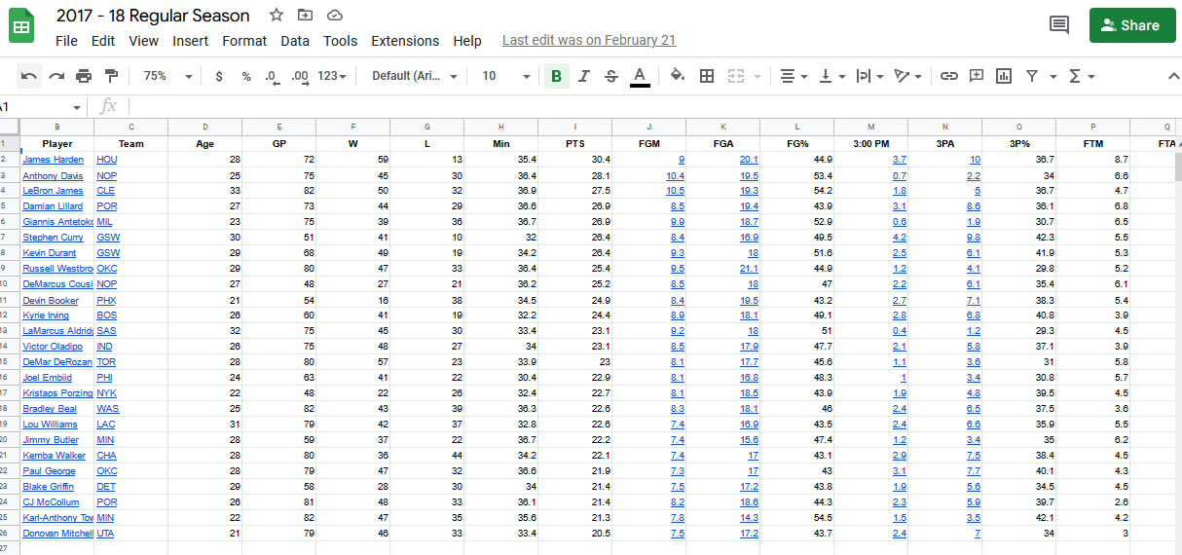

1. Create a sheet for the past five regular season

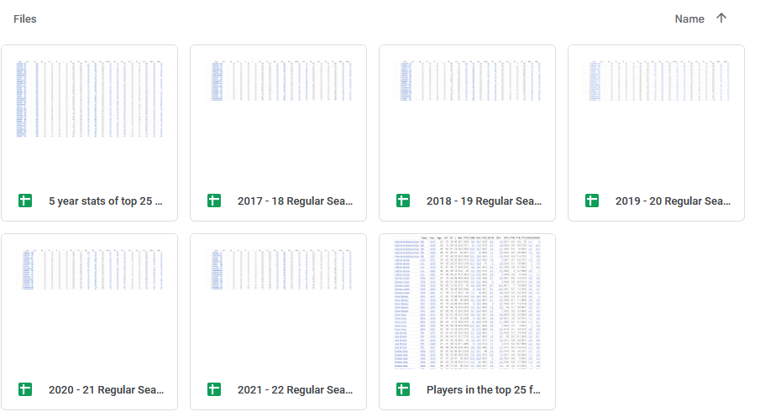

1. Next, we will create an excel sheet of players that are ranked top 25 for the past 5 years, make sure to add the data from each year next to each player.

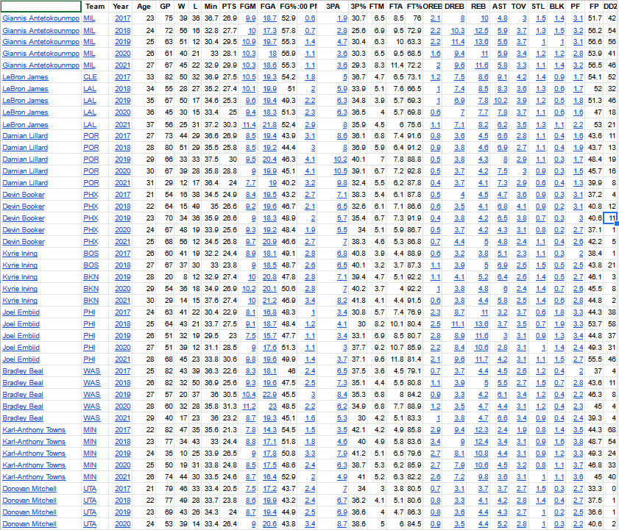

Step 2: import to SAP

**Explain what this step is for.** This step is to …

1. Import your data to SAP so we can then make charts and predictions
2. Login to SAP with your account
3. Create a folder to store all your information one place   
   
4. Create a model > From CSV or Excel file > select your excel sheet > import > use the first row as header.
5. make sure to set your data points as a measure and general information as “General”
6. This is what it should look like

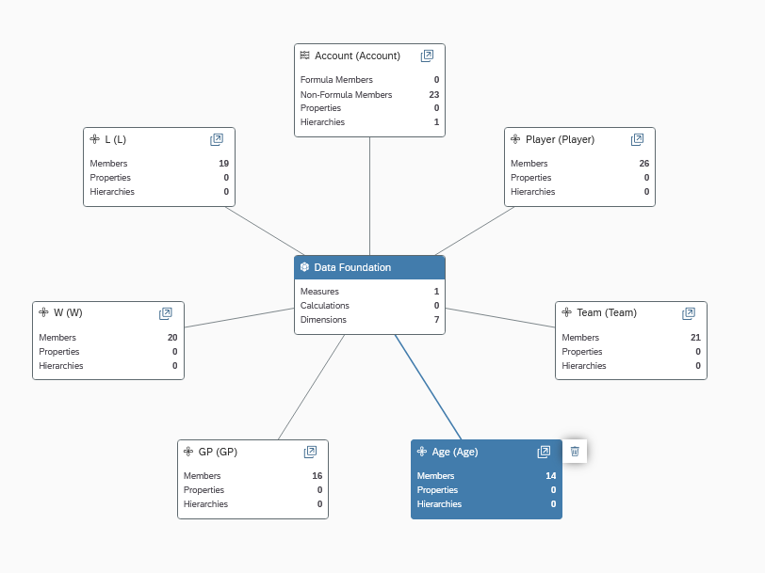

1. repeat the steps for each year of data you have
2. lastly import your top ranked players for the last 5 years

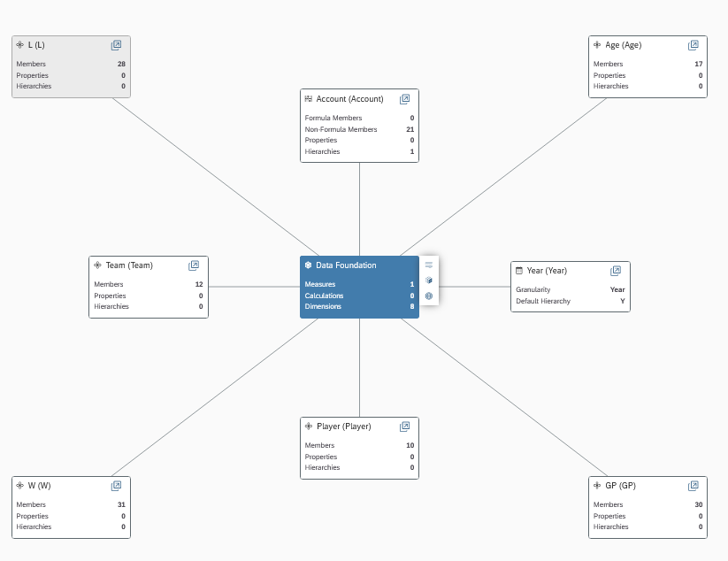

Step 3: Visualization

**Explain what this step is for.** This step is to…

1. To visualize player statistics and create dynamic information with updated states, and to make forcastes on the current season.
2. Create a story and import dynamic stats for each year of data we have

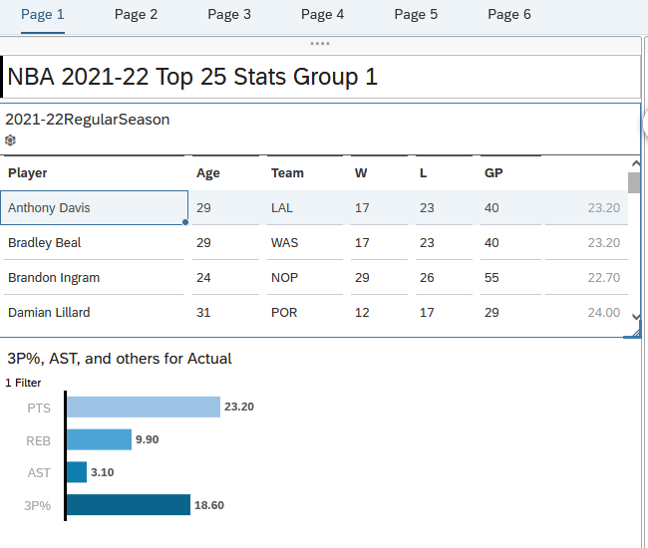

1. Repeat this step for each year, make sure to link the correct data set to each page
2. Once all 5 years are in we are going to create a chart with the top 25 ranked players for the past 5 years.
3. Create a time series chart and import the data for the top 25 ranked players for the past year with stats one each year.

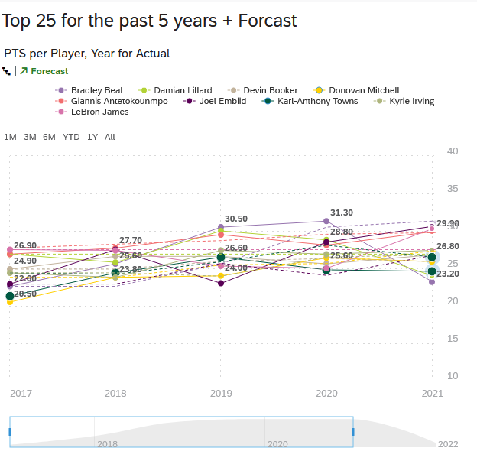

1. Once you have this chart, we are going to apply forecasting and compare to current stats

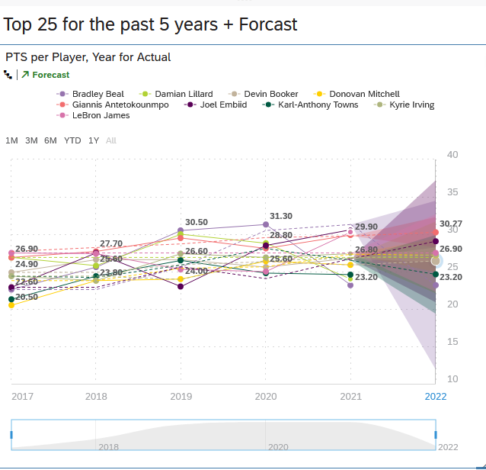

References

* 1. URL of Data Source, <https://www.nba.com/stats/players>
  2. URL of your Github,
  3. URL of References, <https://www.sportsline.com/nba/expert-projections/simulation/> , <https://fantasydata.com/nba/fantasy-basketball-projections>